Plant Developmental Biology
Prof. Shri Ram Yadav
Department of Biotechnology
Indian Institute of Technology, Roorkee
Lecture - 03
Characteristics of Plant Growth and Development - II

Welcome to the second lecture of Characteristic of Plant Growth and Development. So, if we recall in the first lecture we have discussed the primary growth, primary growth and development, secondary growth and development, lateral growth and development. The axis along which the growth and development occurs, the points or the region of the plants where the meristematic activities are positioned and how they are maintained and coordinated during the process of plant growth and development.
(Refer Slide Time: 01:05)
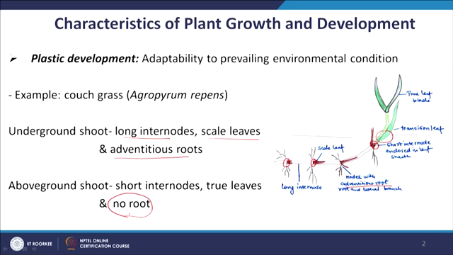
So, now we will continue this lecture of characteristic of plant growth and development with another characteristic of plant development which is Plasticity. It is extremely important for the plants; considering the fact that plants are sessile in nature. They cannot move from one place to another place which means that they have to face all the environmental disturbance or all the environmental condition just by standing at one place. And, to cope with this change in the environment they have adopted a very nice mechanism and which is plastic in nature.
So, the plasticity is basically an adaptability to prevailing environmental condition. I will take couple of example for it and you will appreciate how developmental plasticity is adopted or it is acquired by the plants.
If you take this example, this is couch grass. In the crouch grass basically it’s shoot grows below the ground as well as above the ground. And, what happens when the shoots are growing underground. Underground means it has a very different environmental condition than the above ground. Underground the light intensity is less, oxygen availability and other factors which are very different than the above ground.
You can see when the shoot is growing underground it has a developmental program which is giving rise to long internode, and leaf like structure which is called scale leaf and more important that at every node you can see lot of adventitious root development.
So, there is a developmental program which is going on here already, but once this growing shoots reaches the ground; once it is coming outside the ground it switches its developmental program. There is a change, the first thing what happens is that now it start making short internode.
So, the internode length is reduced to do that it has to change; it’s the basic program of developmental biology. And, another thing that now there is a formation of true leaf blade like structure. And also this shoot at the node it is no longer making the roots. So, what are the changes it has to do developmentally?
It has changed its program for making long internode to the short internode. It has major changes in their program of the leaf development. Now, the leaf is different and more when it was underground it was having active developmental program for adventitious root development. But, once it is coming above ground it has to shut down the program of adventitious root development.

